**Abstract:** In this project we have taken Parkinson’s disease as an example to test our project work. Parkinson’s is a disorder of central nervous system that affects movement often including tremors. Nerve cell damage in the brain causes dopamine levels to drop, leading to the symptoms of Parkinson’s. This disease requires medical diagnosis. Treatment can help but this condition can’t be cured. Lab tests or imaging is often required. It is a chronic disease which can last for years or even lifetime.

Parkinson’s disease is a progressive nervous system disorder that affects movement. Symptoms start gradually, sometimes starting with a barely noticeable tremor in just one hand. Tremors are common but the disorder also commonly causes stiffness or slowing of movement. Although Parkinson’s can’t be cured medications might significantly improve a person’s symptoms. Parkinson’s signs and symptoms may include Tremor, Slowed movement, rigid muscles, impaired posture and balance, Loss of Automatic movements, Speech changes and writing changes. Causes of Parkinson’s include genetics, certain Environmental triggers, the presence of lewdly bodies, Alpha synuclein is found within lewdly bodies. Parkinson’s is often accompanied by additional problems which may be treatable like Thinking Difficulties, Depression and emotional changes, Swallowing problems, Chewing and eating problems, Sleep problems and sleep disorders, etc. As from the above knowledge it is clear that the detection of Parkinson’s is a lengthy procedure and is difficult to carry out manually therefore in order to ease the procedure ai application is necessary.

**Introduction:** Artificial Intelligence in healthcare is the use of complex algorithms and software to emulate human cognition in the analysis of complicated medical data. Some rare diseases are difficult to detect. In some cases there are a lot of parameters that determine the accuracy of diagnosis of disease. Which might results in delayed or misdiagnose resulting in inaccurate treatment. The actual percentage of missed diagnoses VS correct, accurate diagnoses are difficult to determine although experts put the rate at around 5% for outpatients. This project aims in combating the errors while detecting a disease (Parkinson’s) and accomplish the accuracy of positivity of a person having Parkinson’s.

**Literature Review:** The Data in the project used is acquired from Parkinson Data Set UCL Machine learning repository. It consists of details of various cases which are further compared with the input data in order to determine the accuracy of detection of Parkinson. The data includes medical tests info of previous patients for comparison with the actual input data. Medical test parameters like DFA (Direct Fluorescent Antibody), RPDE, PPE, number of pulses, mean period pulses, Standard deviation period pulses. It also consists of data of sample tests taken on 8 different days and are tabulated based on their tqwt kurtosis values. Kurtosis is a statistical measure that defines how heavily the tails of a distribution differ from normal distribution in this case it shows the difference in the statics of actual and normal medical tests. Pandas and numpy libraries are imported for the required functional implementations like reading a .csv file. Further functions imported include train_test_split from sklearn.model_selection library, Perceptron from sklearn.linear_model, accuracy_score from sklearn.matrices. By comparing with all the medical test results in the table the accuracy is determined.

| **id** | **gender** | **PPE** | **DFA** | **RPDE** | **numPulses** | **numPeriodsPulses** | **meanPeriodPulses** | **stdDevPeriodPulses** | **locPctJitter** | **...** | **tqwt_kurtosisValue_dec_28** | **tqwt_kurtosisValue_dec_29** | **tqwt_kurtosisValue_dec_30** | **tqwt_kurtosisValue_dec_31** | **tqwt_kurtosisValue_dec_32** | **tqwt_kurtosisValue_dec_33** | **tqwt_kurtosisValue_dec_34** | **tqwt_kurtosisValue_dec_35** | **tqwt_kurtosisValue_dec_36** | **class** |
| --- | --- | --- | --- | --- | --- | --- | --- | --- | --- | --- | --- | --- | --- | --- | --- | --- | --- | --- | --- | --- |
| **0** | 0 | 1 | 0.85247 | 0.71826 | 0.57227 | 240 | 239 | 0.008064 | 0.000087 | 0.00218 | ... | 1.5620 | 2.6445 | 3.8686 | 4.2105 | 5.1221 | 4.4625 | 2.6202 | 3.0004 | 18.9405 | 1 |
| **1** | 0 | 1 | 0.76686 | 0.69481 | 0.53966 | 234 | 233 | 0.008258 | 0.000073 | 0.00195 | ... | 1.5589 | 3.6107 | 23.5155 | 14.1962 | 11.0261 | 9.5082 | 6.5245 | 6.3431 | 45.1780 | 1 |
| **2** | 0 | 1 | 0.85083 | 0.67604 | 0.58982 | 232 | 231 | 0.008340 | 0.000060 | 0.00176 | ... | 1.5643 | 2.3308 | 9.4959 | 10.7458 | 11.0177 | 4.8066 | 2.9199 | 3.1495 | 4.7666 | 1 |
| **3** | 1 | 0 | 0.41121 | 0.79672 | 0.59257 | 178 | 177 | 0.010858 | 0.000183 | 0.00419 | ... | 3.7805 | 3.5664 | 5.2558 | 14.0403 | 4.2235 | 4.6857 | 4.8460 | 6.2650 | 4.0603 | 1 |
| **4** | 1 | 0 | 0.32790 | 0.79782 | 0.53028 |  |  |  |  |  |  |  |  |  |  |  |  |  |  |  |  |

**Proposed Methodology:** We have saved the data about Parkinson’s disease in an exel file Parkinsons_disease.csv which comprise of data sheets regarding the Medical report cases in a tabular format. From this file we have selected data with header 1. This selected data works as an input of the program and is further compared with all the test cases in the Parkinsons_disease.csv file to produce the result in the form of accuracy of a person having Parkinson by importing accuracy_score form sklearn.matrices.

**Result and discussion:** The result of this project comprise of the probability that the person checked has Parkinson’s if the result gives lower accuracy value then the chances of that person having Parkison disease decreases. We can also say that if the accuracy in the final output is greater than 0.5 then chances are that person checked has Parkinson else if less than 0.5 then the chances of the person having Parkinson’s decrease.

**Conclusion:**  The primary aim of our project was the diagnosis of Parkinson’s disease. This program can also be applied on other diseases by using required data.

**References:**

[www.parkinsons.org](http://www.parkinsons.org)

[www.sciencedirect.com](http://www.sciencedirect.com)

[www.parkinsonsnewstoday.com](http://www.parkinsonsnewstoday.com)

[www.healthline.com](http://www.healthline.com)

[www.mayoclinic.com](http://www.mayoclinic.com)

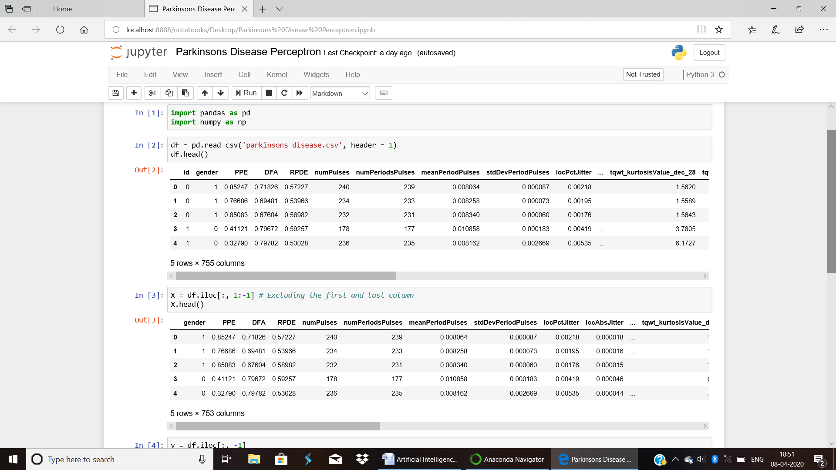

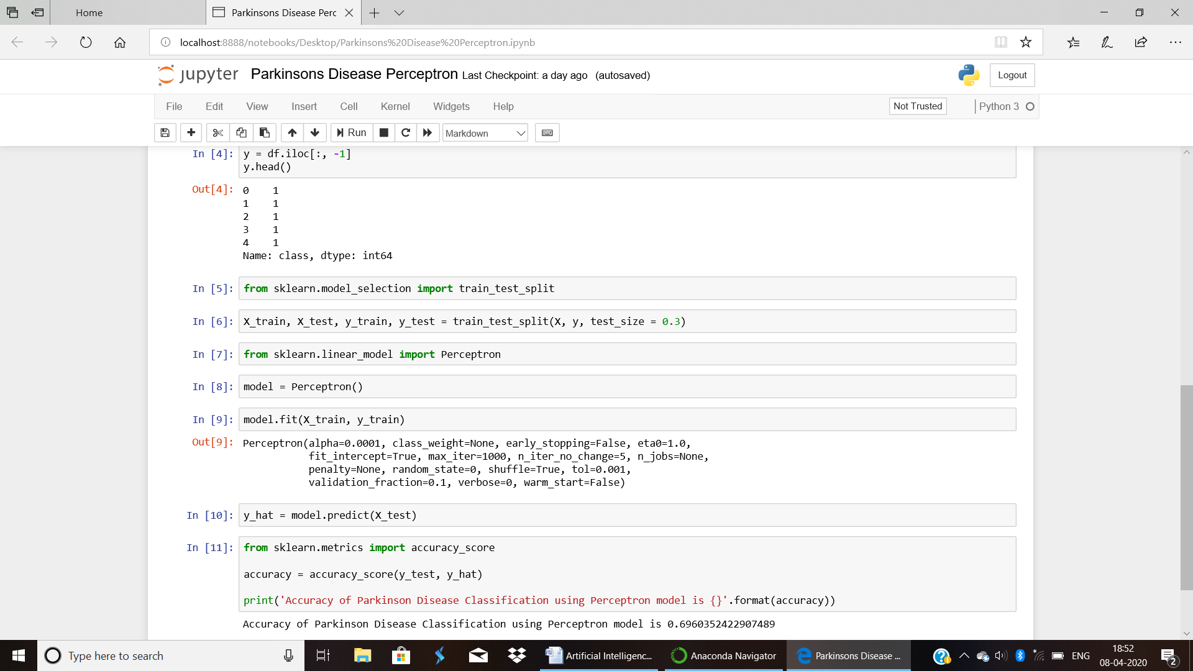

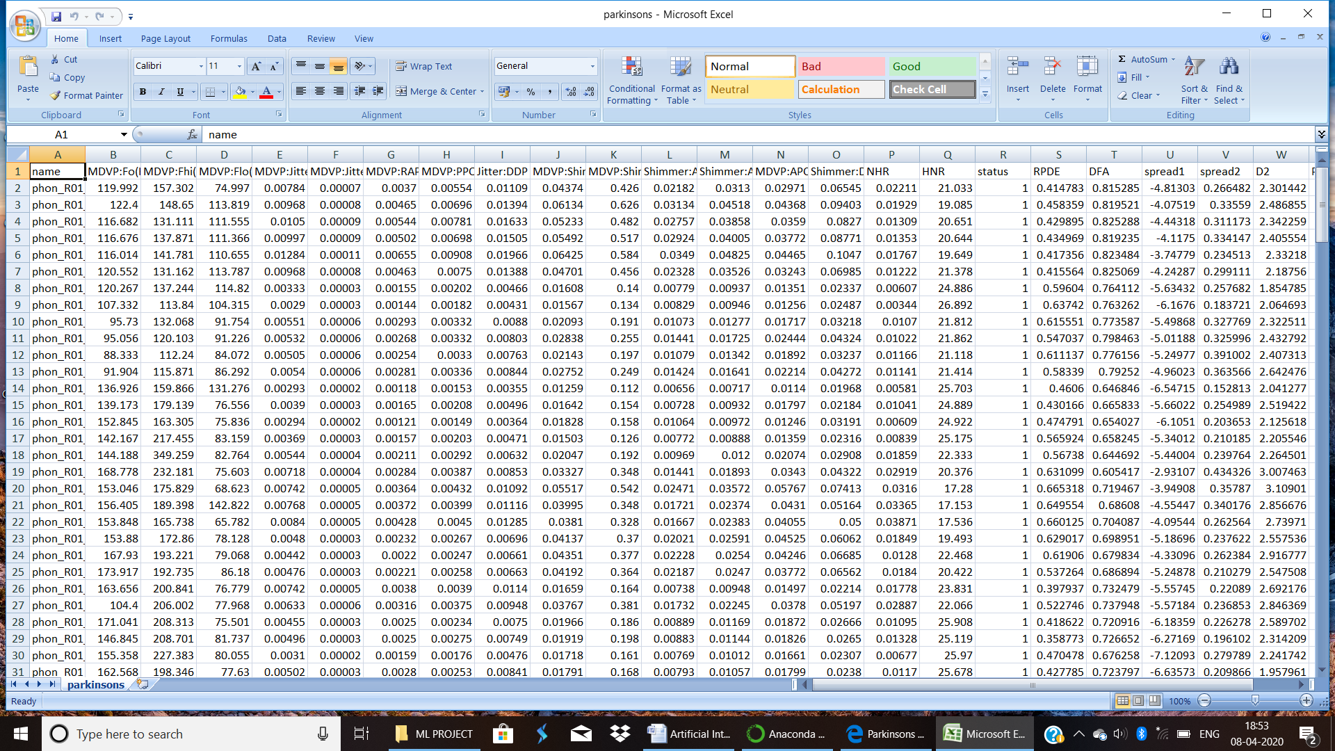

**Plagiarism:**